DECISIONS DELEGATED TO OFFICERS

Decision title: | Transfer by sale of land between 22 and 23 Harts Close, Kidlington to Oxford City Housing (Development) Limited (OCH(D)L) and the purchase of the completed development by Oxford City Council from OCH(D)L.
Decision date: | 19 February 2021
Source of delegation: | Cabinet on 29 May 2019 agreed to delegate authority to the Assistant Chief Executive to:  - Approve the sale of sites as set out in the OCHL business plan to OCHL providing that such sales comply with the mechanism set out in paragraph 31 of this report and s123 of the Local Government Act 1972, and are made on the basis that following development all affordable housing units at the sites would be purchased back by the Council through the Housing Revenue Account.  - Approve and facilitate the agreed purchase by the HRA of all affordable housing units at the OHCL development sites.
What decision was made? | - To authorise the transfer by sale of land between 22 and 23 Harts Close to Oxford City Housing (Development) Limited for a consideration of £1  - To authorise the transfer by purchase of the land and two affordable housing units from Oxford City Housing (Development) Limited by the Council’s Housing Revenue Account for a consideration of £770,000 in total.
Purpose: | To authorise the transfer by sale of land between 22 and 23 Harts Close, Kidlington to Oxford City Housing (Development) Limited (OCH(D)L) and Oxford City Council to purchase the completed development.  As part of Oxford City Council’s City Executive Board decision on 17 March 2016 to establish Oxford City Housing Limited it was agreed that the Council’s wholly owned Housing Company OCH(D)L would develop new affordable housing with a range of tenures.  OCH(D)L has obtained planning permission to deliver 2 affordable homes (18/01308/F from Cherwell District Council) on land at 22 and 23 Harts Close, Kidlington.
Reasons: | To support the delivery of affordable housing.  The viability appraisals undertaken show that the scheme is within the parameters set for the Housing Revenue Account.  The scheme is supported by £95,000 of Oxfordshire Growth Deal Affordable Housing grant.
Decision made by: | Caroline Green, Assistant Chief Executive  Decision taken in consultation with the Head of Financial Services, the Head of Law and Governance and the Cabinet Member for Affordable Housing.
Other options considered: | Not to transfer the properties would represent a missed opportunity to deliver affordable housing and support the delivery of the OCHL business plan.
Documents considered: | Report to Assistant Chief Executive, 10 September 2020.
Key or Not Key: | Key
Wards significantly affected: | None
Declared conflict of interest: | None
This form was completed by:  Name & title:  Date: | Andrew Brown  Committee and Member Services Manager  22 February 2021

Approval checklist

Approver | Name and job title | Date
Senior officer(s) | Caroline Green, Assistant Chief Executive  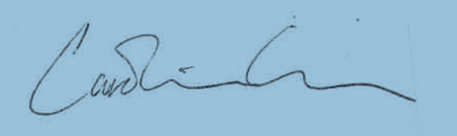 | 19 February 2021
Head of Financial Services if | Nigel Kennedy, Head of Financial Services  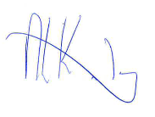 | 19 February 2021
Head of Law and Governance if | Susan Sale, Head of Law and Governance  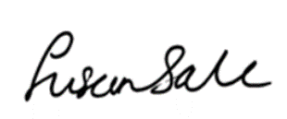 | 19 February 2021

